**Roll No: A-36**

# Finolex Academy of Management and Technology,Ratnagiri

**Department of MCA**

# Course:- MCAL13 Advanced Database Management System Lab

**Practical No 01: Data Partitioning**

# Q.1]

1. Create book table (book_id(pk),title,author,price,book_rating) with range partition on rating with rating 1,2 and 3 for three different partitions. Insert at least 10 records in the table.
2. Display all the books with the rating 3 and price in the range 200 and 1000.

->

**A)** create table book2(  book_id number(10) primary key, title varchar(20), author varchar(20), price number(10), book_rating number(5)

)

partition by range(book_rating)

(

partition p1 values less than(2), partition p2 values less than (3), partition p3 values less than (4)

);

insert into book2 values(1,'Collection of data','Karl',550,3); insert into book2 values(2,'Data Science','Pear',950,4); insert into book2 values(3,'Programming with C++','Stanlev',1000,5); insert into book2 values(4,'Advance Java','Uttam roy',1500,5); insert into book2 values(5,'Database Management System','Ravi chopra',5000,3); insert into book2 values(6,'Programming with C','Satinder',950,3); insert into book2 values(7,'Software Project Management','P.S.Gill',750,4); insert into book2 values(8,'Web Technologies','Mishra',1000,2); insert into book2 values(9,'Mathematics for CS','Aagrwal',750,5); insert into book2 values(10,'Advance Database','Mark',800,4); select*from book2; **Output:**

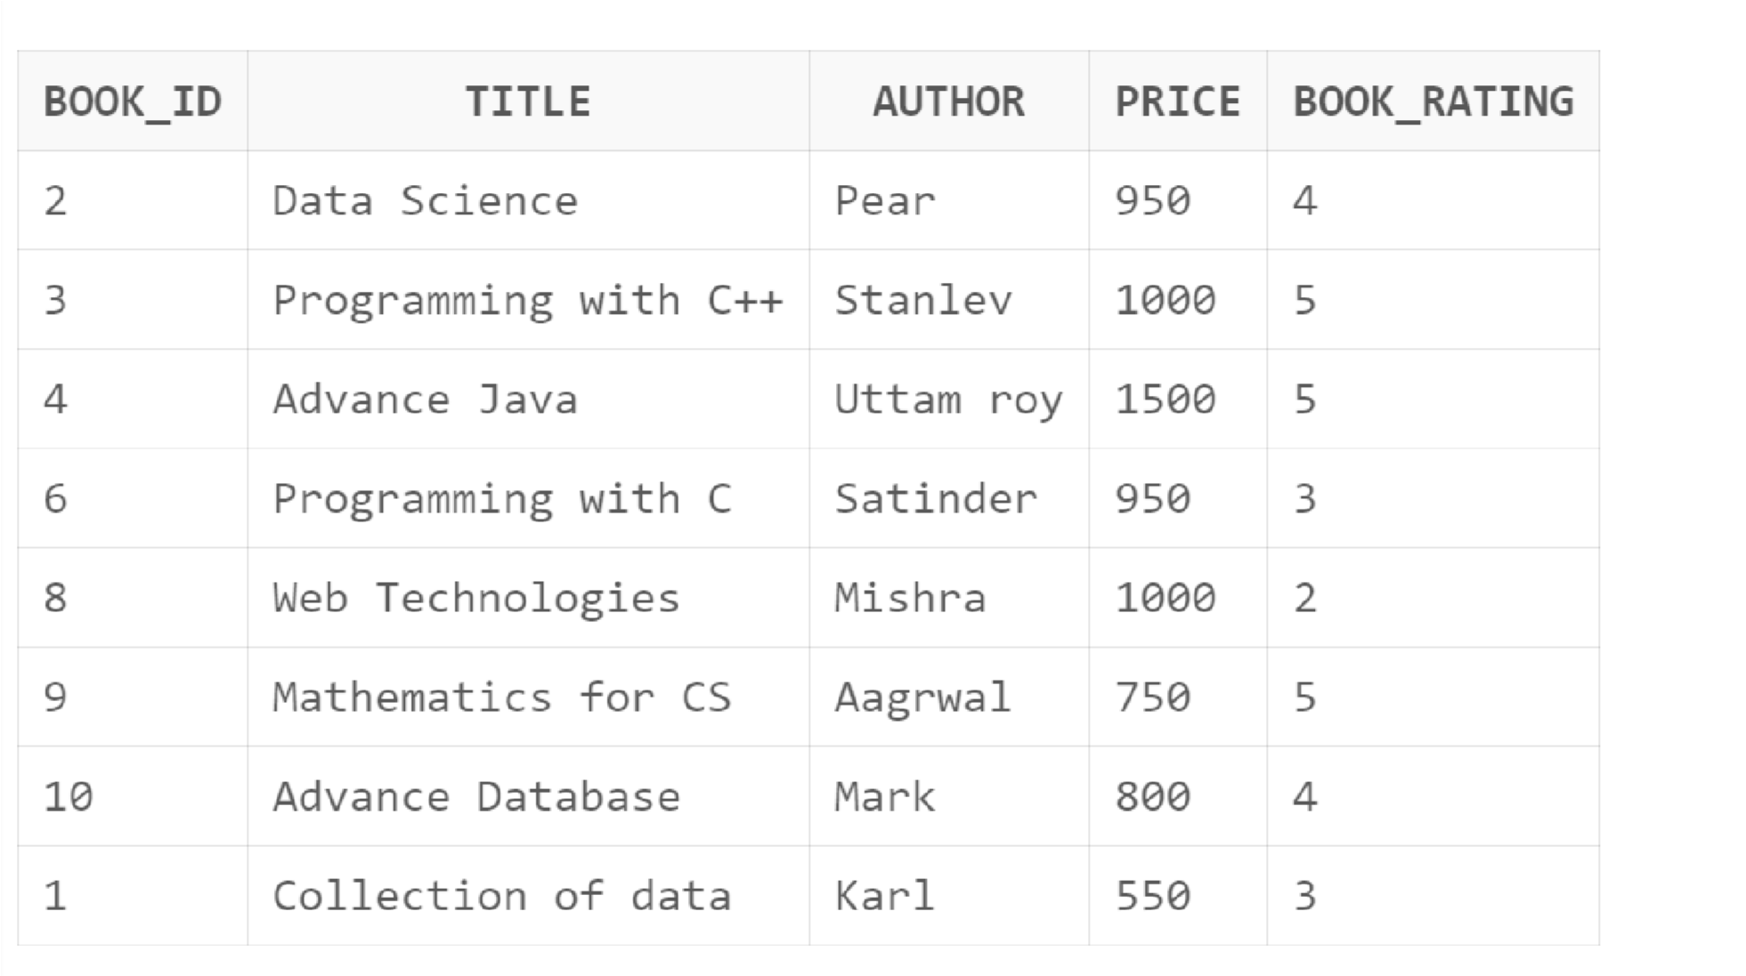

**B)** select*from book2 where book_rating=3 and price between 200 and 1000;

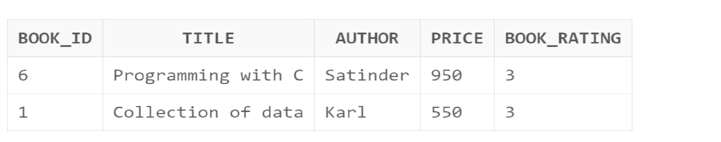

**Q2]** A) Create 3 partition in table cabinet using Range partition on cid Column ofcabinet(cid,mem_name,address,state_rep,phone_number,sal)

P1 cid &lt; 101;P2 &lt; cid &lt;501; P3 cid &lt;1001. Insert at least 10 records in the table.

B) Display the contents of third partition

**->** A) create table Cabinet( cid number(10), mem_name varchar(20), address varchar(20), state_rep varchar(20), phone_number number(10), sal number(10)

)

partition by range(cid)( partition p1 values less than (101), partition p2 values less than (501), partition p3 values less than (1001)

);

insert into Cabinet values(101,'Pooja','Ratnagiri','Maharashtra',7517765520,45000); insert into Cabinet values(236,'Prajkta','Lanja','Maharashtra',9452135726,15000); insert into Cabinet values(356,'Siddhi','Rajapur','Maharashtra',7418529630,18000); insert into Cabinet values(485,'Sayali','Mumbai','Maharashtra',9638527412,20000); insert into Cabinet values(569,'Ashwini','Thane','Maharashtra',7894561230,60000); insert into Cabinet values(645,'Rizwana','Kolhapur','Maharashtra',7538694213,69520); insert into Cabinet values(769,'Nitesh','Raigad','Maharashtra',8697534216,85421); insert into Cabinet values(836,'Akshay','Devrukh','Maharashtra',7894561580,36528); insert into Cabinet values(912,'Saurabh','Khorninko','Maharashtra',9518476230,36521); insert into Cabinet values(1000,'Avita','Pachal','Maharashtra',8695321479,6520); select * from Cabinet; **Output:**

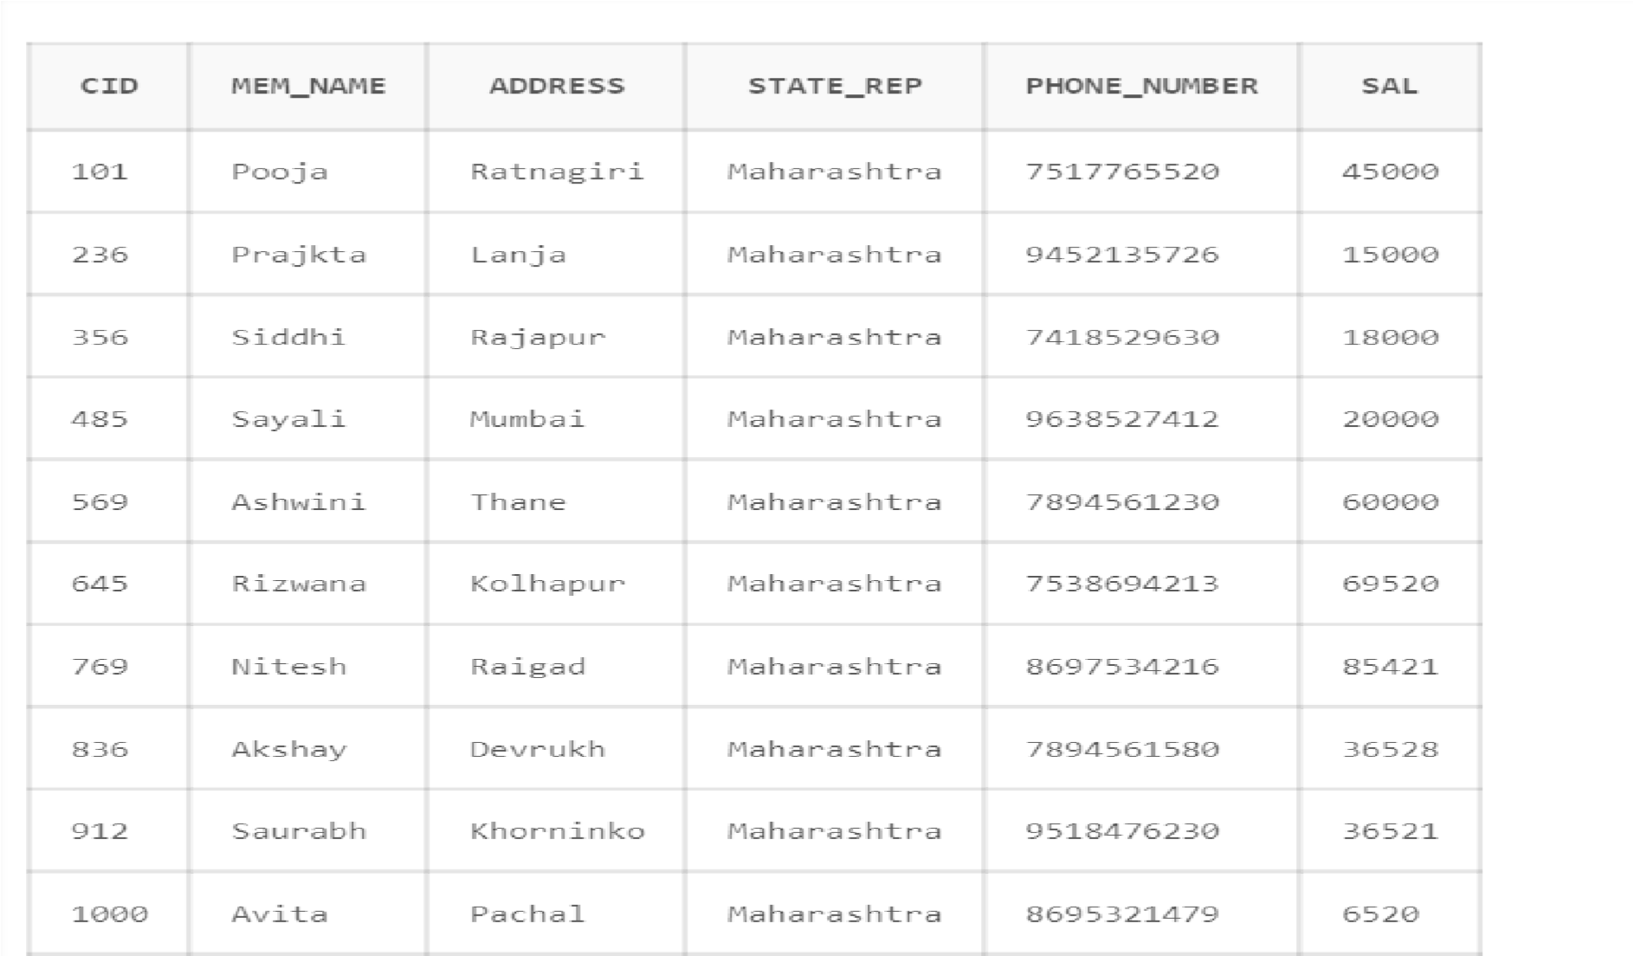

# B)

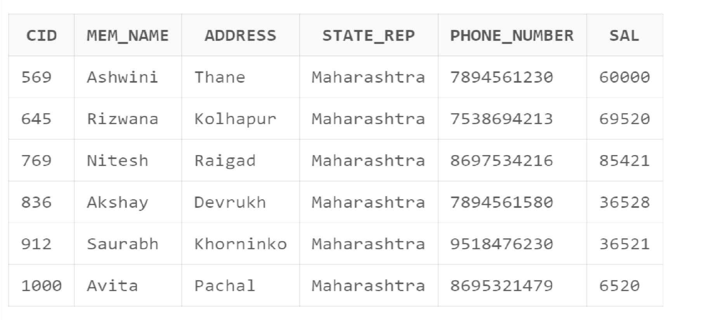

**Q3]**A) Create table Employee with attributes empid,name,age,salary and joining date byusing hash partition based on employee salary with minimum 3 partitions. Insert at least 10 records in the table.

B) Display the information of the employee in the third partition

-> **A)** create table employee( empid number(10), ename varchar(20), age number(10), sal number(10), join_date Date

)

partition by hash(sal)( partition p1, partition p2, partition p3

);

insert into employee values(1,'Pooja',24,26560,'02-mar-2012'); insert into employee values(2,'Tanuja',25,24020,'03-apr-2010'); insert into employee values(3,'Gayatri',28,20520,'10-jan-2012'); insert into employee values(4,'Archana',23,22520,'01-jun-2014'); insert into employee values(5,'Prajkta',26,23000,'10-mar-2012'); insert into employee values(6,'Siddhi',27,36520,'06-apr-2019'); insert into employee values(7,'Ashwini',26,46520,'04-jun-2014'); insert into employee values(8,'Sayali',26,56520,'15-jan-2010'); insert into employee values(9,'Avita',22,66520,'06-dec-2012'); insert into employee values(0,'Runali',25,76520,'20-mar-2020'); select * from employee; **Output:**

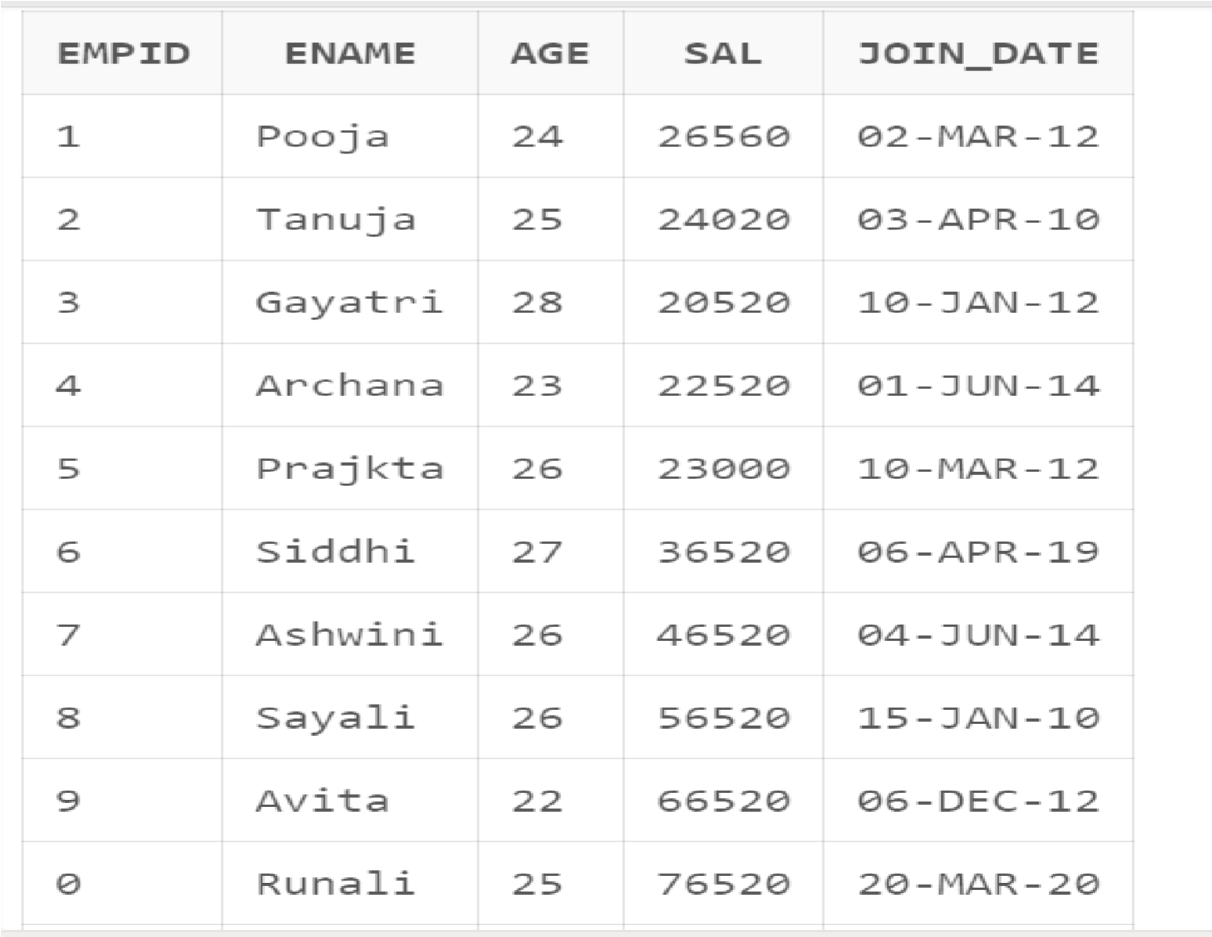

**B)** select * from employee partition(p3); **Output:**

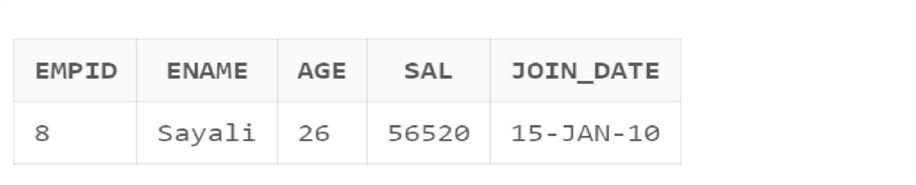

**Q4]**A)Create test_record(test_id,test_type,patient_name,employee_no,labno,result)with list partition on result field as below:

P1=(positive)

P2=(negative)

Insert at least 10 records in the table.

B)Display the test_records which have negative result.

-> **A)** create table test_record( test_id number(10), test_type varchar(10), patient_name varchar(20), employee_no number(10), labno number(10), result_p varchar(10)

)

partition by list(result_p)

(

partition P1 values('positive'), partition P2 values('negative')

);

insert into test_record values(1,'covid','aditya',562,5,'negative'); insert into test_record values(2,'TB','pooja',456,9,'positive'); insert into test_record values(3,'cancer','shubham',965,10,'positive'); insert into test_record values(4,'malaria','yuraj',869,69,'negative'); insert into test_record values(5,'Tumor','Harsh',852,69,'positive'); insert into test_record values(6,'Typhoid','aadii',365,86,'positive'); insert into test_record values(7,'Tyroid','archana',256,12,'positive'); insert into test_record values(8,'cancer','sourabh',96,63,'negative'); insert into test_record values(9,'TB','siddhu',965,169,'positive'); insert into test_record values(10,'cancer','sayali',698,96,'positive'); select * from test_record;

# Output:-

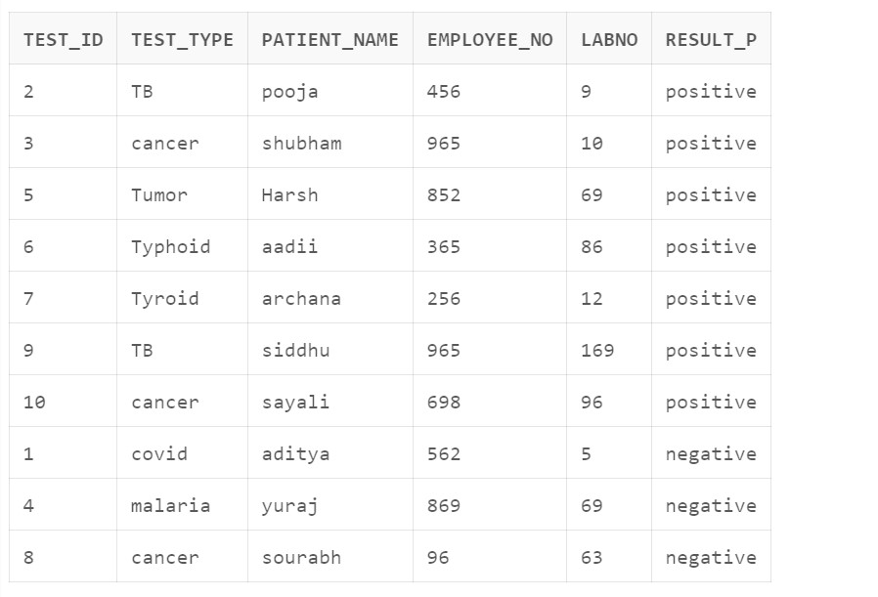

**B)** select * from test_record where result_p='negative';

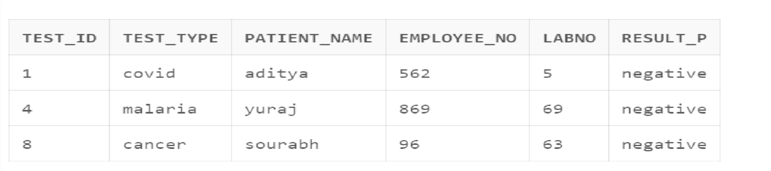

**Q.5]** A) Create table Bank with fields BankId, BName, Location. Partition the Bank tablebased on Location as per following.

BK1 = (Mumbai, Pune, Nashik), BK2 = (Lucknow, Kanpur, Varanasi)

BK3 = (Chandigarh, Mohali, Amritsar), BK4 = (GandhiNagar, Ahmedabad, Surat)

Insert 10 records in Bank table.

B) Add values “Ratnagiri” in BK1 partition

-> **A)** create table bank( bankid number(10), bname varchar(20), blocation varchar(20)

)

partition by list(blocation)( partition bk1 values('Mumbai','Pune','Nashik'), partition bk2 values('Lucknow','Kanpur','varanasi'), partition bk3 values('Chandigarh','Mohali','Amritsar'), partition bk4 values('GandhiNagar','Ahmedabad','Surat')

);

insert into bank values(1,'Bank of India','Ratnagiri'); insert into bank values(2,'Bank of Maharashtra','Kanpur'); insert into bank values(3,'HDFC','Mumbai'); insert into bank values(4,'IDBI','Pune'); insert into bank values(5,'ICICI','varanasi'); insert into bank values(6,'Axis','Surat');

insert into bank values(7,'State Bank of India','Mohali'); insert into bank values(8,'CityBank','GandhiNagar'); insert into bank values(9,'Saraswat Bank','Lucknow'); insert into bank values(10,'Hyderbad Bank','Nashik');

select * from bank;

# Output:

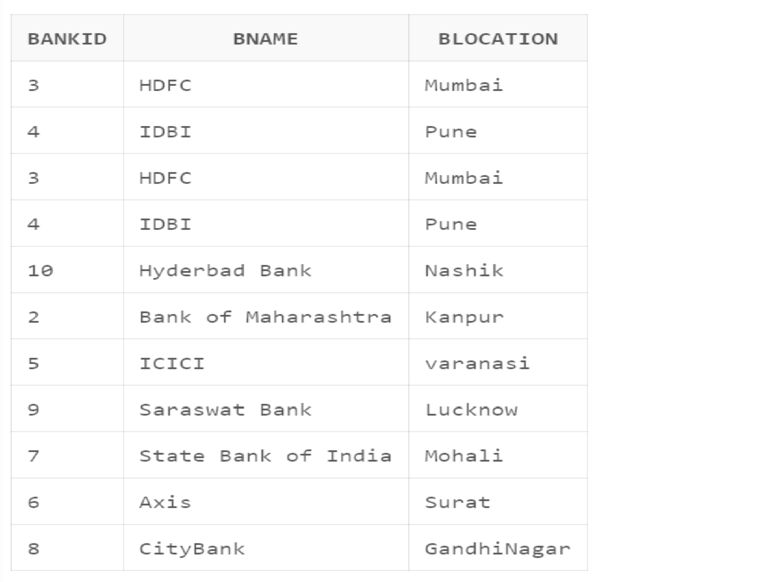

**B)** alter table bank modify partition bk1 add values('Ratnagiri'); insert into bank values(11,'Bank of Baroda','Ratnagiri');

select * from bank partition(bk1);

# Output:

